Text identification using OpenCV, Tesseract (OCR) and deep neural network

**Introduction to Text Identification**

Text identification is the process of detecting and recognizing text within images or videos. This process is critical for applications like automatic document scanning, license plate recognition, extracting text from digital media, and more. By leveraging computer vision, Optical Character Recognition (OCR), and deep learning models, we can achieve high accuracy in identifying and extracting text from complex visual environments.

**Theory**

**1. OpenCV (Open Source Computer Vision Library):** OpenCV is a popular open-source library that provides tools for image and video processing. It can preprocess images by performing tasks like grayscale conversion, thresholding, noise reduction, and contour detection, making the image suitable for text extraction. Preprocessing plays a vital role in improving OCR accuracy by enhancing image quality.

**2. Tesseract (OCR Engine):** Tesseract is one of the most powerful and widely used OCR engines. It converts preprocessed images into text by recognizing characters in the image. Tesseract works in multiple stages:

* **Preprocessing**: Applies techniques like binarization, which converts images into black and white.
* **Segmentation**: Splits the image into regions, identifying areas that contain text.
* **Recognition**: Detects individual characters, and with the help of pattern matching, converts them into a string.
* **Post-processing**: Corrects the recognized text using dictionaries and language models to ensure the accuracy of the output.

**3. Deep Neural Networks (DNNs) for Text Detection:** Text detection can be improved using DNNs, especially when working with complex images where text might be distorted, rotated, or occluded. Deep learning techniques, such as **Convolutional Neural Networks (CNNs)** and **Recurrent Neural Networks (RNNs)**, are often used for more robust text detection and recognition. The role of DNNs in text identification includes:

* **Feature Extraction**: Extracts relevant features from an image that help identify text regions.
* **Object Detection**: Locates bounding boxes around text regions, even in complex backgrounds.
* **End-to-End Systems**: Some modern approaches integrate DNNs for both text detection and recognition, ensuring a more accurate and automated OCR process.

Combining these three tools (OpenCV, Tesseract, and DNNs) can significantly enhance the performance of text identification systems, making them more accurate and adaptable to various real-world challenges.

**Problem Statement**

Given an image or a video frame containing text, the objective is to identify and extract the text with high accuracy using a combination of **OpenCV**, **Tesseract OCR**, and a **Deep Neural Network**. This involves detecting the text location, processing the image to enhance readability, and using a neural network to handle complex recognition tasks.

**Steps Involved in Text Identification**

The process of text identification can be broken down into several stages:

1. **Text Detection**: Locating the region in the image where text is present.
2. **Image Preprocessing**: Enhancing the image quality for better text recognition.
3. **Text Recognition (OCR)**: Extracting text from the detected regions using OCR.
4. **Post-Processing with DNN**: Using a neural network to refine and improve recognition results, particularly in challenging scenarios like distorted or handwritten text.

**Role of OpenCV in Text Detection**

OpenCV is typically used for:

* **Preprocessing**: Resizing, grayscale conversion, thresholding, noise reduction, and edge detection, which improve the quality of the input image for OCR.
* **Text Detection**: Using techniques like contour detection, image pyramids, and connected components to identify text regions in an image. OpenCV helps in localizing text areas, which are then passed to Tesseract for recognition.

**Example Methods for Text Detection:**

* **Edge Detection**: Detecting edges of letters and words using the Canny Edge Detector.
* **MSER (Maximally Stable Extremal Regions)**: Used for detecting text in natural scenes.
* **Contours**: Identifying text blobs by finding contours in an image.

**Optical Character Recognition (OCR) with Tesseract**

Once text regions are detected, the next step is to recognize the text using Tesseract. Tesseract OCR works by:

1. **Reading the image**: It converts images to binary format for better text extraction.
2. **Recognizing Characters**: Tesseract applies machine learning models to detect characters and convert them into text.
3. **Post-Processing**: Correcting common OCR errors and converting the recognized characters into readable text.

Tesseract supports various languages and fonts, making it versatile for multilingual OCR tasks.

**Image Preprocessing for Better OCR:**

* **Thresholding**: Converts grayscale images to binary images for clearer text extraction.
* **Dilation and Erosion**: Helps in closing gaps and smoothing text edges.
* **Noise Removal**: Removing artifacts that might interfere with OCR accuracy.

**Enhancing OCR using Deep Neural Networks**

While Tesseract is highly effective, combining it with a **Deep Neural Network (DNN)** can significantly improve recognition accuracy, especially in complex scenarios. A **Convolutional Neural Network (CNN)** can be trained to:

* **Enhance text detection**: Accurately identify distorted or noisy text regions.
* **Refine character recognition**: Handle challenging cases such as handwritten text, varying font sizes, and irregular spacing.

The DNN architecture can be designed to learn from large datasets of labeled images, improving the system’s ability to recognize characters, even in tough conditions. The neural network acts as a secondary layer that improves the final output of the OCR engine by making the recognition process more robust and error-tolerant.

**Diagram**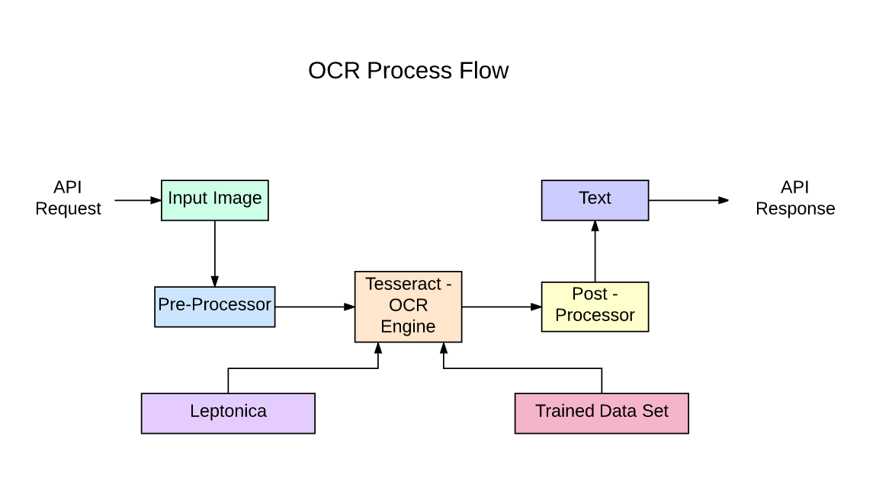

**Advantages of Text Identification using OpenCV, Tesseract, and DNNs**

1. **High Accuracy**:
   * The combination of traditional image processing (OpenCV) and advanced text recognition (Tesseract with DNNs) can lead to highly accurate results, even for complex or noisy images.
2. **Support for Multiple Languages**:
   * Tesseract supports more than 100 languages, making it suitable for multilingual text identification tasks.
3. **Cost-Effective**:
   * OpenCV and Tesseract are open-source libraries, which means they are free to use for both personal and commercial projects. This makes it an affordable solution for text extraction.
4. **Customizable Pipelines**:
   * With OpenCV, users can fine-tune the preprocessing stage to optimize the quality of text before it reaches the OCR system. This flexibility is critical for adapting the solution to specific requirements.
5. **Scalable and Fast**:
   * Using DNNs, especially with hardware acceleration like GPUs, the system can scale to handle large datasets efficiently, making it suitable for real-time applications like text extraction from live camera feeds or video streams.

**Disadvantages of Text Identification using OpenCV, Tesseract, and DNNs**

1. **Sensitive to Image Quality**:
   * Poor-quality images (e.g., low resolution, motion blur, uneven lighting) can significantly affect the accuracy of text recognition. Preprocessing techniques can help, but they cannot completely solve issues arising from bad image quality.
2. **Computationally Intensive**:
   * Deep learning models, particularly when working with large images, require substantial computational resources. This might slow down the process unless GPU acceleration is used.
3. **Limited Accuracy on Complex Layouts**:
   * Tesseract may struggle with complex document layouts (e.g., multi-column text, rotated or skewed text). While deep neural networks improve accuracy, performance on highly distorted or complex layouts still requires manual adjustment or post-processing.
4. **Dependency on Preprocessing**:
   * The success of the OCR process heavily relies on how well the images are preprocessed. This often requires extensive tuning based on the dataset (e.g., noise removal, edge detection), which can be time-consuming.

**Challenges and Limitations**

Despite the power of OpenCV, Tesseract, and DNN, there are some challenges in text identification:

1. **Low-Quality Images**: Blurry or low-resolution images can hinder OCR performance.
2. **Complex Backgrounds**: Text embedded in noisy or complex backgrounds may result in inaccurate detection.
3. **Non-Uniform Text**: OCR systems struggle with distorted, rotated, or non-uniform text.
4. **Handwritten Text**: Recognizing handwritten text can be a challenge for traditional OCR systems, though DNNs can be trained to improve accuracy in these cases.

**Applications of Text Identification**

Text identification is widely used in numerous fields, such as:

1. **Document Scanning**: Converting scanned paper documents into machine-readable text.
2. **License Plate Recognition**: Automatically recognizing vehicle plates for traffic monitoring.
3. **Scene Text Recognition**: Extracting text from images in natural scenes, such as road signs and billboards.
4. **Automated Data Entry**: Extracting text from invoices, receipts, and forms to automate business processes.
5. **Assistive Technology**: Helping visually impaired individuals by recognizing text and converting it to speech.

**Conclusion**

The combination of OpenCV, Tesseract, and deep neural networks offers a powerful solution for text identification tasks, providing robust and accurate results in many scenarios. While there are challenges, particularly with image quality and computational requirements, advances in DNNs have made it possible to significantly improve OCR performance. By leveraging these technologies, organizations can automate tedious data extraction tasks, enhance productivity, and open new possibilities for text-based applications.